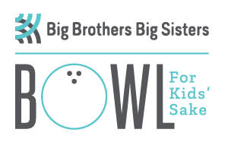
Quesnel Bowl for Kids Sake 2020
Team Entry Form
This Year’s Theme: YABBA DABBA DOOOO FLINTSTONES!
Friday Nite March 6, 2020

Register Online: www.bigbrothersbigsistersofquesnel.ca
Team Captain Name_______________________________________________________ Email:___________________________________ Phone # _______________________
Team Name: (if you have one) ___________________________________

List team member names: Please include first and last names.
Include yourself as one if you are bowling. Please indicate (y and age ex Y13) for Youth Bowlers.
1._______________________________________________________
2._______________________________________________________
3._______________________________________________________
4._______________________________________________________
5._______________________________________________________
See lane schedule in package and choose your bowling time – (given out on first come basis)
1st choice 4:30-6:00 pm _____________
2nd choice 6:00- 7:30 pm _____________
3rd choice 7:30 – 9:00 pm _____________
Please return this entry to our office, 468 B Reid Street or Fax: 250-992-0937
Email: bbbsques@goldcity.net Phone: Joanie 250-992-7257 if you have any questions.

Please let your team each participant will get a small prize for participation.

