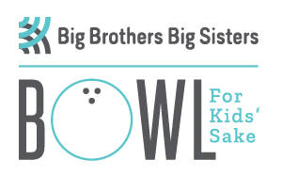

MAKE IT MORE FUN AND ISSUE A CHALLENGE TO ANOTHER AGENCY/BUSINESS!!!!!

To all Teams: This year add some friendly competition to your Bowl for Kids Sake experience and challenge another team to participate in the event. Phone and challenge your competitor today! Notify us of your challenge! Call 250 992-7257. Email: bbbsques@goldcity.net

BOWL FOR KIDS’ SAKE, March 1, 2019
CHALLENGE SHEET
WE __________________________________
Challenger
ARE ENTERING _____ TEAM(S) AND WE CHALLENGE YOU TO MEET OR BEAT OUR TOTAL PARTICIPATING.

Challengee

ACCEPT THIS CHALLENGE BY CALLING THE
“BOWL FOR KIDS’ SAKE” COORDINATOR.
Joanie at 250-992-7257

